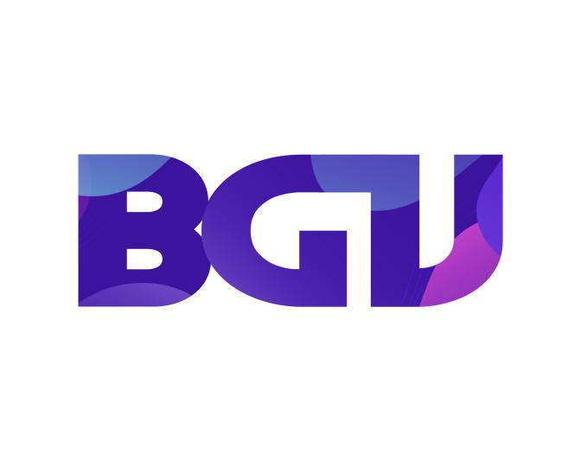

**ENGLISH**

**1. Introduction**

Through easy-to-remember English short stories, children learn valuable lessons about humanities and life skills. Since then, both help children apply language to natural communication situations, while building for children noble living values and personality. BGV Gifted Training School with many years of teaching experience will equip students with basic to advanced knowledge to help them confidently communicate in English.

**2/Class time :**

* Basic class: 3 months (5 times/week)
* Advanced class: 4 months (5 times/week)

**3/The content of the course :**

**I CAN READ :**

**1. I CAN READ :**

- This level is for those who have basic knowledge of sound splitting and writing the English alphabet. Level I CAN READ enhances training in English skills:

+ Fluent

+ Flexible Intonation Read fluently

+ Expressing well Write correct English grammar

**2. I CAN READ PLUS :**

- This level is essential for children to begin with learning English. Level I CAN READ PLUS will help your baby :

+ Identify and correct English pronunciation

+ Expand your English vocabulary

+ Build confident communication skills

+ Write fluent alphabet

**DISCOVERS :**

**DISCOVER 1 :**

- The results-oriented course helps children not only promote knowledge but also develop communication and interaction skills in society. Each lesson is designed in the direction of high interaction between children and teachers.

+ Develop listening skills - through storytelling hours, exchanges and other classroom activities.

+ Form sound concepts - through songs and activities that help your child develop rhymes and phonemes.

+ Improve your vocabulary - through engaging classroom activities on topics.

+ Develop social skills - through interactive classroom activities.

**DISCOVER 2 :**

- In this course, students develop the perception that each word spoken is a combination of its own small sounds. We call this "emerging phonemic awareness".+ Improve listening skills - through storytelling hours, exchanges and other classroom activities.

+ Identify the beginning and ending sounds in words - through fun transcription activities.

+ Identify differences between words and syllables - through phonemic activities.

+ Expand your vocabulary - through engaging classroom activities on topics.

**DISCOVER 3 :**

- Students are completely immersed in the English environment and interact with teachers through a variety of fun activities. These activities are designed to teach children the important “phonetic skills” needed to read independently.

+ Identify the beginning, end, and middle sounds of words - through phonemic activities.

+ Identify differences between words and syllables - through “phonological” activities.

+ Phonics - by identifying the sounds of common letters.

+ Vocabulary expansion - through engaging, topic-based classroom activities.

**4/The tuition fees of the courses are as follows :**

- For I can read: The course lasts 3,5-months with tuition of 2000$ and we are committed to the best teaching quality for the children.

- For Discover: The course lasts 4-month course with a cost of 2500$, we are committed to the best teaching quality for our children.